**LAB 8 REPORT – Aaron Bruner**

In this project each student must segment a range image based upon surface normals. A range image of a chair is given at the course website (note that the reflectance image is only for visualization and will not be used for the lab; make sure you work with the range image). Some C-code is also provided to convert the pixels into 3D coordinates. The segmentation process will use the image grid for grouping pixels, but will use the 3D coordinates for calculating surface normals for region predicates.

Original Image Original Image (Threshold 130) Colored Segmented Image

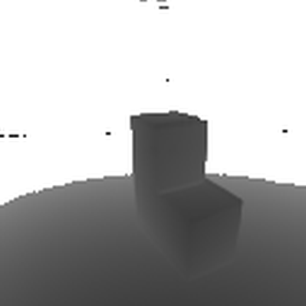 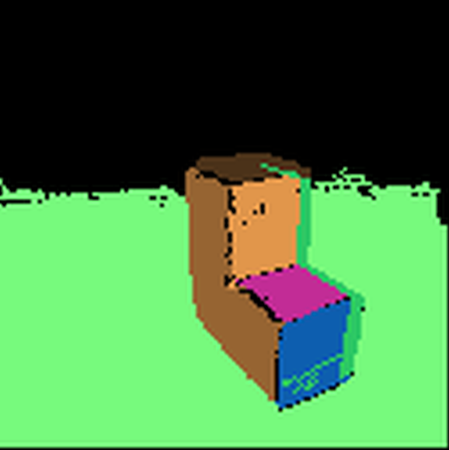

A distance value of 3 was the only feasible option. Using values less than 3 or greater than 3 heavily distort the image.

For region growing a cutoff angle of 0.75 was used. Lower or larger values made the image look worse.

The output image is a pretty good representation of the original image. It captures the areas with minimal error.